# NOTES

# While unnecessary, I wanted to include a program flow stepping through each of the options in the # sequence of mailroom’s objectives. This is what I got from my last debugging run.

--------------------------------------------------------------------------------------------------------------

MAIL ROOM MENU

--------------------------------------------------------------------------------------------------------------

Select one of the three options:

[A] Send a Thank you [B] Create a Report [C] Create Letters for All Donors [D] Quit

Menu Selection: a

Leaving menu...

Enter the name of the person you are writing to (or enter 'list' to see a list of names or Q to quit)

First Name: micah

Last Name: braun

That name is not in the Donor list. Do you want to add it to the list? y

- - - - - - - - - - - - - - - - - - - - - - - - - - - - - - - - - - - - - - - - - - - - - - - - - - - - - - - -

NAMES

- - - - - - - - - - - - - - - - - - - - - - - - - - - - - - - - - - - - - - - - - - - - - - - - - - - - - - - -

Rudolph Soares Efrain Lager

Josef Mistretta Mee Heine

Joye Agostini Tanya Essex

Rachelle Levan Micah Braun

Vena Ussery

Enter in the donation amount from Donor Micah Braun: $200000

Micah Braun has donated $200,000.00

Display Donor Email? (Y/N): y

- - - - - - - - - - - - - - - - - - - - - - - - - - - - - - - - - - - - - - - - - - - - - - - - - - - - - - - -

Dear Micah,

Thank you for your continued support through your contribution of $200,000.00 towards our Foundation's fundraising goal.

Best wishes,

Foundation Board of Directors

- - - - - - - - - - - - - - - - - - - - - - - - - - - - - - - - - - - - - - - - - - - - - - - - - - - - - - - -

Enter the name of the person you are writing to (or enter 'list' to see a list of names or Q to quit)

First Name: q

--------------------------------------------------------------------------------------------------------------

MAIL ROOM MENU

--------------------------------------------------------------------------------------------------------------

Select one of the three options:

[A] Send a Thank you [B] Create a Report [C] Create Letters for All Donors [D] Quit

Menu Selection: a

Leaving menu...

Enter the name of the person you are writing to (or enter 'list' to see a list of names or Q to quit)

First Name: list

- - - - - - - - - - - - - - - - - - - - - - - - - - - - - - - - - - - - - - - - - - - - - - - - - - - - - - - -

NAMES

- - - - - - - - - - - - - - - - - - - - - - - - - - - - - - - - - - - - - - - - - - - - - - - - - - - - - - - -

Rudolph Soares Efrain Lager

Josef Mistretta Mee Heine

Joye Agostini Tanya Essex

Rachelle Levan Micah Braun

Vena Ussery

Enter the name of the person you are writing to (or enter 'list' to see a list of names or Q to quit)

First Name: micah

Last Name: braun

That value is already in the list! Do you want to proceed with that selection? (Y/N): y

Enter in the donation amount from Donor Micah Braun: $500

Micah Braun has donated $500.00

Display Donor Email? (Y/N or Q): n

Enter the name of the person you are writing to (or enter 'list' to see a list of names or Q to quit)

First Name: q

--------------------------------------------------------------------------------------------------------------

MAIL ROOM MENU

--------------------------------------------------------------------------------------------------------------

Select one of the three options:

[A] Send a Thank you [B] Create a Report [C] Create Letters for All Donors [D] Quit

Menu Selection: b

Leaving menu...

Generate Donor report? (Y/N): y

Generating Donor report... [Press Enter]

- - - - - - - - - - - - - - - - - - - - - - - - - - - - - - - - - - - - - - - - - - - - - - - - - - - - - - - -

NAMES | DONATION AMOUNT | NUMBER OF GIFTS | AVG. GIFTS

- - - - - - - - - - - - - - - - - - - - - - - - - - - - - - - - - - - - - - - - - - - - - - - - - - - - - - - -

Micah Braun $200,500.00 2 $100,250.00

Tanya Essex $ 75,000.00 2 $ 37,500.00

Rachelle Levan $ 12,100.00 5 $ 2,420.00

Josef Mistretta $ 7,500.00 4 $ 1,875.00

Mee Heine $ 4,600.00 4 $ 1,150.00

Vena Ussery $ 4,000.00 8 $ 500.00

Rudolph Soares $ 1,335.00 3 $ 445.00

Efrain Lager $ 795.00 9 $ 88.34

Joye Agostini $ 600.00 2 $ 300.00

Generate Donor report? (Y/N): n

Do you want to quit back to the main menu? (Y/N): y

Quitting... [Press Enter]

--------------------------------------------------------------------------------------------------------------

MAIL ROOM MENU

--------------------------------------------------------------------------------------------------------------

Select one of the three options:

[A] Send a Thank you [B] Create a Report [C] Create Letters for All Donors [D] Quit

Menu Selection: c

Leaving menu...

Proceed to write letters to all donors in donor list? (Y/N) y

Enter the file path where you want to write the letters - don't forget to use two

'\\' as file separators to make sure it is compatible if using Windows - (e.g. 'C:\\': C:\\Users\\Micah\\Desktop\\Comp_Sci\\Python\\Assignments\\Lesson 4\\letters\\

Files being written to C:\\Users\\Micah\\Desktop\\Comp_Sci\\Python\\Assignments\\Lesson 4\\letters\\...

Done!

‘’’

Here is a .PNG of what where the files went on my PC

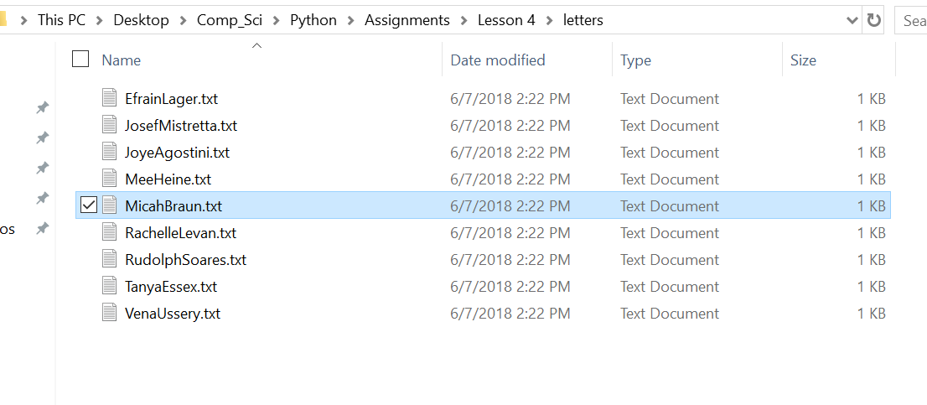

‘’’

Proceed to write letters to all donors in donor list? (Y/N) n

Exiting back to menu [Press ENTER]

--------------------------------------------------------------------------------------------------------------

MAIL ROOM MENU

--------------------------------------------------------------------------------------------------------------

Select one of the three options:

[A] Send a Thank you [B] Create a Report [C] Create Letters for All Donors [D] Quit

Menu Selection: d

Exiting Program...[Press ENTER]

Process finished with exit code 0